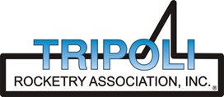
Tripoli Motor Testing Division
223 NC Highway 54 West
Chapel Hill, NC 27516
(919) 357 5681 (c)
November 3, 2020

Gary Rosenfield
RCS Rocket Motor Components, Inc.
2113 West 850 North Street
Cedar City, UT 84721

Dear Mr. Rosenfield,

The Aerotech L1940X-P reload kit was tested on May 22, 2021 and complies with NFPA 1125. The motor is certified for hobby rocketry use by the members of the Tripoli Rocketry Association and all approving organizations with reciprocal certifying agreements.

Motor Manufacturer RCS Rocket Motor Components, Inc.
Manufacturer’s Designation L1940X-P [for the 75/3840 hardware]
Propellant Propellant X
TMT Nomenclature 4329 L1939

Diameter 2.964” 75.29 mm
Overall Length 22.063” 560.39 mm
Outside of Motor Tube 1.688” 42.86 mm

Loaded Mass 8.5 lb 3855.5 g
Propellant Mass 4.02 lb* 1825 g*
Burnout Mass 4.216 lb 1912.4 g
* = data provided by manufacturer

Burn time 2.231 ± .031 sec

Total Impulse 973.24 lbf.s 4329.2 N.s
Max Impulse 521.22 lbf 2318.5 N
Average Impulse 435.97 lbf 1939.3 N
Number of Motors Tested 3

Casing Temp. [NFPA 1125 7.4.1] Passed

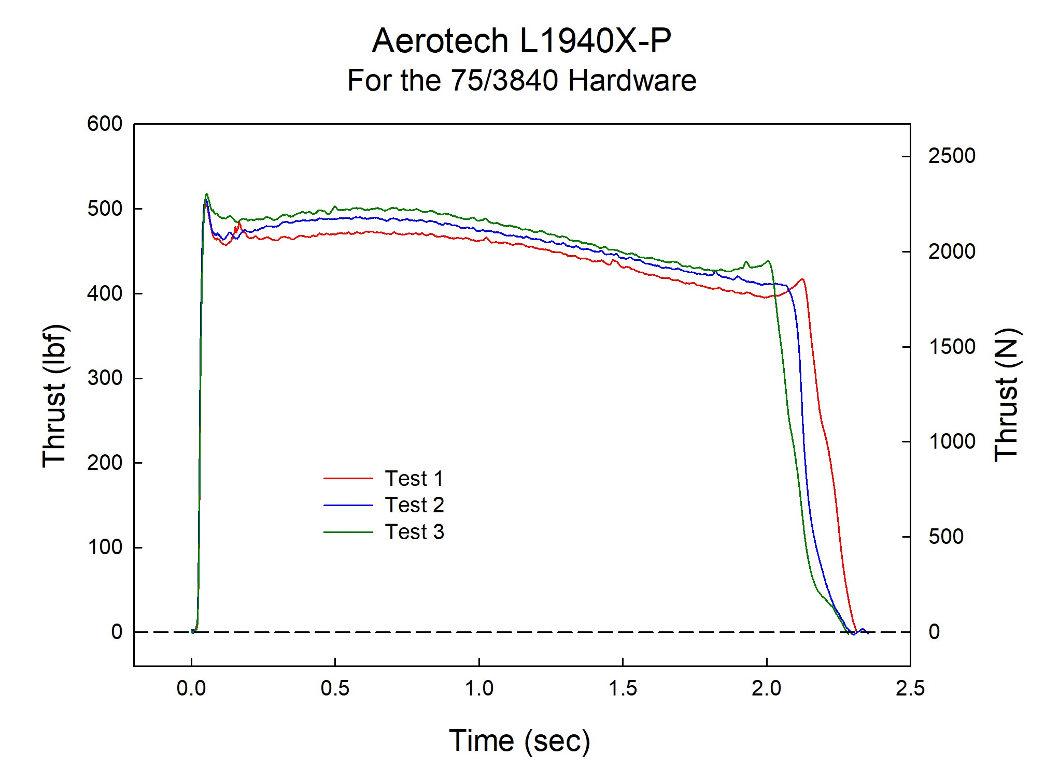

Sincerely,

Alan C. Whitmore
Chair, Tripoli Motor Testing

